Michael Shear

2/26/2023

Cst 325

Journal 3

Matrices

I’ve learned how matrices are used to transform vectors into movements through multiplication and scaling. For example scaling can be used to uniformly increase the size of a vector by a constant number, and multiplication can be used to transform and move a vector. The only case where multiplication is commutative is with the identity matrix. If the order of multiplication is changed for any other matrix there will be a completely different result. I think one of the concepts that took me a while to understand was the multiplication of two vectors because it could be difficult to organize and very easy to make a mistake and get the completely wrong result. Yet I was able to see a pattern in how the indexes of the matrices incremented based on the position within the matrix.

What was challenging at first was the multiplication which I had to work out on paper to give me a better understanding of the order of operations. After working the code out on paper I translated what was on the paper into the code, I did have a few syntax errors but was able to get them resolved. Messaging Jaden and Ulrich proved to be very helpful with making progress on the homework. I plan to utilize office hours more as well as using tutoring resources available at the CLC.

Something else that I found interesting was these transformations can be interpreted differently based on the type of projection used. For example in a perspective projection this leads to the center of the image being faraway. Whereas if viewed from an orthographic projection it makes a 3d representation in a 2d space. The final thing I didn't realize was how gimbal lock can severely affect animations when a complete degree of rotation is lost. I saw some examples of gimbal lock and some of the results are truly baffling. However I definitely know a lot more about matrices than I did previously. 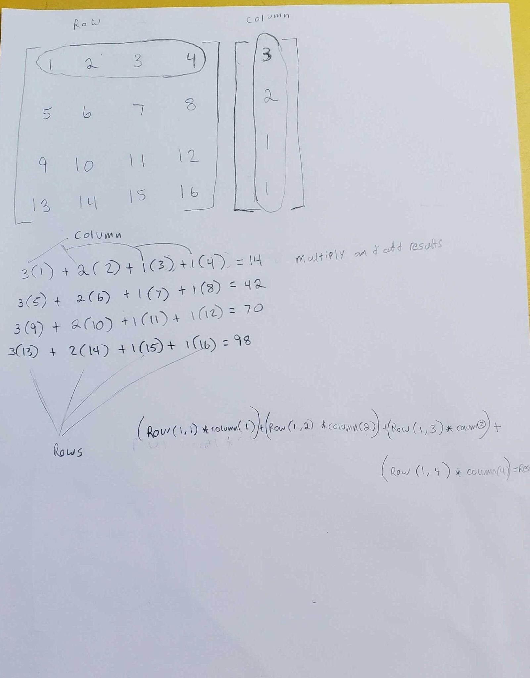

Working it out on paper

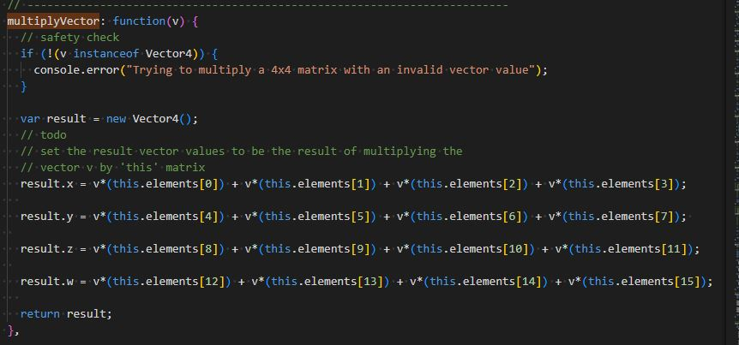

Code with some minor errors

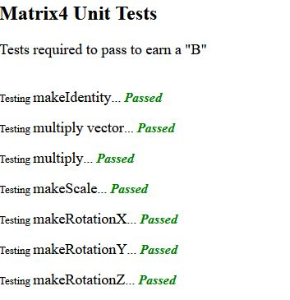

Finally making some progress